### Set up Adobe Effects CS6

"one_shot" Output Module template and “5fps_setting” Render Setting must be manually set in After Effects before running ag_gen_raw_data.jsx. Before setting up these templates , do the following steps:

1. Open a project in After Effects.
2. Select a composition and press “Ctrl+M” (, which will add this composition to the render queue)

#### Set up "one_shot" Output Module template

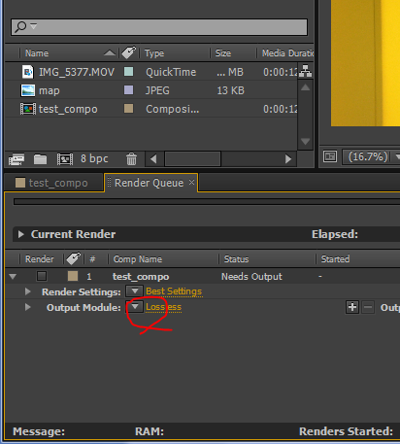

Choose “Make Template”….

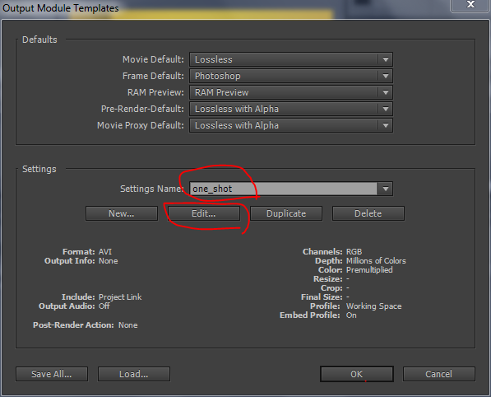

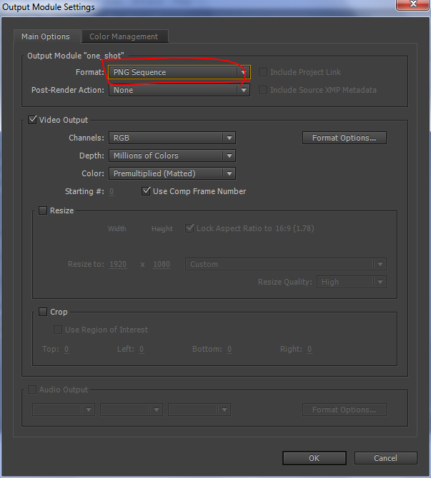

#### Set up “5fps_setting” Render Setting

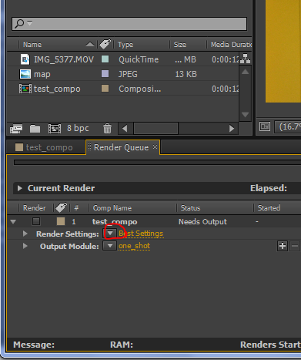

Choose “Make Template”….

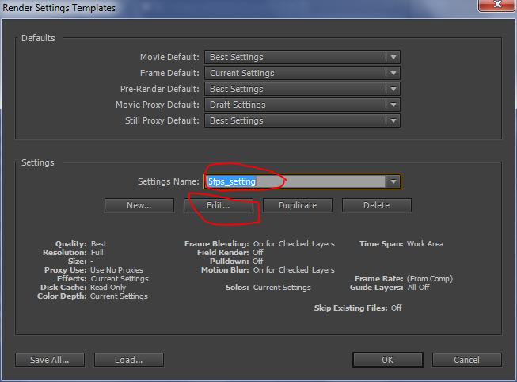

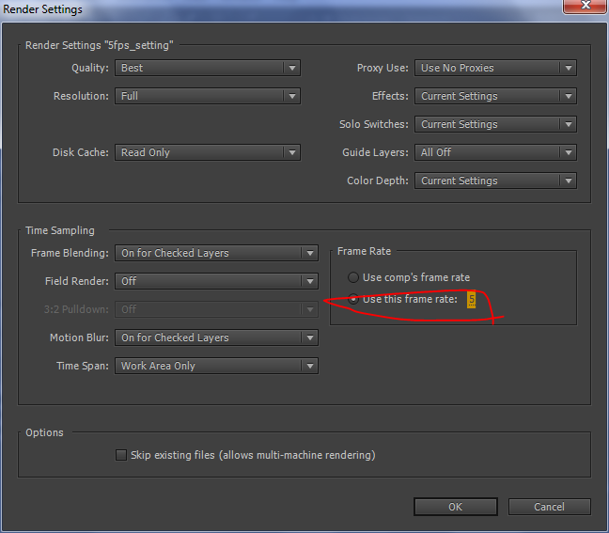

### Install other Modules

Install the fowllowing modules:

npm install xml2js

npm install xmlbuilder

npm install mongodb

npm install mongoose